**Identifying Shopping Trends using Data Analysis**

A Project Report

submitted in partial fulfillment of the requirements

of

AICTE Internship on AI: Transformative Learning

with

TechSaksham – A joint CSR initiative of Microsoft & SAP

by

**Khushi Gupta**

**Email: khushig2882@gmail.com**

Under the Guidance of

**Jay Rathod**

**ACKNOWLEDGEMENT**

I express my heartfelt gratitude to everyone who contributed to the successful completion of my project, *"****Identifying Shopping Trends using Data Analysis****."*

Firstly, I would like to **Jay Rathod**, for his valuable guidance, encouragement, and constructive feedback throughout the course of this project. Their expertise and insights have been instrumental in shaping this work. I would also like to thank **Pawan Kumar Sumohana**, who made sure everything was well organised.

I extend my gratitude to **TechSaksham** initiative by **Microsoft** and **SAP** for providing me with the resources and platform to undertake this project.

I am grateful to my peers, friends, and family, whose constant support and motivation have helped me stay focused and inspired during the course of this work.

Lastly, I acknowledge the authors and researchers whose work has provided a strong foundation for my research and analysis in understanding shopping trends through data.

Thank you all for your unwavering support.

Khushi Gupta

#### **ABSTRACT**

In today's rapidly evolving consumer landscape, understanding shopping trends is crucial for businesses to thrive in competitive markets. This project, *"Identifying Shopping Trends using Data Analysis,"* explores the dynamic realm of consumer behaviour through the lens of data-driven insights.

Leveraging real-world datasets and advanced analytical techniques, this study uncovers patterns and preferences that influence purchasing decisions. From identifying seasonal spikes in demand to analysing customer demographics and product affinities, the project provides actionable insights that can drive informed business strategies.

The methodology combines exploratory data analysis (EDA), visualization, and machine learning models to identify correlations and trends. Tools like Python, Pandas, and Matplotlib were employed to process, clean, and interpret data, ensuring accuracy and reliability.

The findings of this project hold the potential to enhance marketing strategies, optimize inventory management, and foster personalized shopping experiences. By bridging the gap between raw data and actionable intelligence, this work showcases the transformative power of data analysis in the retail domain.

This project stands as a testament to the importance of data-driven decision-making in shaping the future of commerce.

**TABLE OF CONTENT**

**Abstract I**

**Chapter 1.**  **Introduction 1**

1.1 Problem Statement 1

1.2 Motivation 1

1.3 Objectives 2

1.4. Scope of the Project 2

**Chapter 2.**  **Literature Survey 3**

2.1 Review of Relevant Literature

2.2 Existing Models, Techniques or Methodologies

2.3 Gaps and Limitations in Existing Solutions

**Chapter 3.**  **Proposed Methodology**

3.1 System Design

3.2 Requirement Specifications

3.2.1 Hardware Requirements

3.2.2 Software Requirements

**Chapter 4.**  **Implementation and Results 6**

4.1 Snapshots of Result

4.2 GitHub Link for code

**Chapter 5. Discussion and Conclusion 14**

5.1 Future Work

5.2 Conclusion

**References** 16

**LIST OF FIGURES**

|  |  |  |
| --- | --- | --- |
| **Figure No.** | **Figure Caption** | **Page No.** |
|  | Overall distribution of customer ages | **9** |
|  | Most commonly purchased items in each category | **9** |
|  | Most purchased category | **10** |
|  | Specific seasons or months where customer spending is significantly higher | **10** |
|  | Most popular payment method among the customers | **11** |
|  | Finding Correlation | **11** |
|  | Do customers who use promo codes tend to spend more than those who don't? | **12** |
|  | frequency of purchases Overall distribution of customer ages | **12** |
|  | Noticeable differences in purchase behavior between different locations | **13** |
|  | Average purchase amount difference between male and female customers | **13** |

**CHAPTER 1**

**Introduction**

* 1. **Problem Statement:**

In an era of fast-paced consumerism, businesses face the constant challenge of understanding and adapting to ever-changing shopping trends. With the rise of e-commerce, diverse customer preferences, and seasonal buying patterns, the retail industry is awash with data but often struggles to extract meaningful insights.

Traditional approaches to identifying shopping trends are either too slow to keep up with the dynamic marketplace or lack the precision required to inform strategic decisions. As a result, businesses risk missed opportunities, inefficient inventory management, and suboptimal marketing strategies.

This project aims to address the pressing need for a data-driven approach to uncover hidden patterns, predict emerging trends, and provide actionable insights. By analysing real-world datasets, the study seeks to empower businesses with the tools they need to enhance customer satisfaction, optimize operations, and maintain a competitive edge in an increasingly data-centric world.

* 1. **Motivation:**

In today’s digital age, data has become the lifeblood of decision-making, yet many organizations struggle to unlock its full potential. The retail industry, in particular, faces a unique challenge: how to interpret vast amounts of consumer data to stay ahead of the curve. Observing how businesses compete for customer attention sparked my curiosity about the underlying patterns that drive shopping trends.

What makes some products go viral? Why do certain customer segments prefer specific brands or categories? How do external factors like seasons or festivals impact buying behavior? These questions inspired me to delve into the fascinating world of data analysis to uncover insights that can answer such questions.

The motivation for this project stems from the belief that actionable insights from data can revolutionize business strategies, enhance customer satisfaction, and improve operational efficiency. By analyzing shopping trends, I aim to contribute to the growing field of data-driven innovation, combining technology with creativity to solve real-world challenges.

This project is not only an opportunity to apply my technical skills but also a chance to make a meaningful impact in an industry where understanding customer behavior is the key to success.

* 1. **Objective:**

The primary objective of this project, *"Identifying Shopping Trends using Data Analysis,"* is to leverage advanced data analytics techniques to uncover, analyze, and predict emerging shopping trends. By doing so, the project aims to empower businesses with actionable insights that can guide strategic decision-making and optimize their operations.

Specific objectives include:

1. **Analyse Consumer Behaviour:** Explore the relationship between customer demographics, purchasing patterns, and preferences to identify key factors influencing shopping trends.
2. **Identify Seasonal Trends:** Investigate how different times of the year—holidays, festivals, or even weather patterns—affect consumer buying decisions.
3. **Segment Customer Groups:** Use data clustering techniques to classify customers into distinct segments based on their purchasing habits and identify which segments are most likely to drive future trends.
4. **Predict Future Trends:** Employ machine learning models to forecast emerging shopping trends and offer businesses a predictive edge in inventory management, marketing, and product offerings.
5. **Provide Strategic Recommendations:** Translate data insights into practical recommendations for businesses to refine their marketing strategies, optimize product assortments, and enhance the customer shopping experience.

This project seeks to demonstrate how businesses can harness the power of data analysis to stay ahead of the curve and make informed decisions that cater to their customers’ evolving needs.

* 1. **Scope of the Project:**

This project focuses on identifying key shopping trends by analyzing customer data from various retail sectors. It includes data collection, cleaning, and preparation, followed by identifying patterns in customer behavior across different segments. Using data analysis techniques, the project aims to uncover trends such as seasonal preferences, popular product categories, and purchasing behavior.

Additionally, predictive models will be developed to forecast future shopping trends, empowering businesses to optimize their marketing strategies, inventory management, and customer engagement. The scope is limited to analyzing available retail data and providing actionable insights to drive business decisions in a competitive market.

**CHAPTER 2**

**Literature Survey**

* 1. **Review relevant literature**

Understanding shopping trends through data analysis has been a widely explored topic in recent years, driven by the growth of big data and advanced analytical tools. Researchers and industry professionals have extensively studied the intersection of consumer behavior, retail trends, and data-driven decision-making.

1. Consumer Behavior and Shopping Patterns  
Studies in behavioral economics and marketing have consistently highlighted the importance of understanding consumer preferences. Research by Kotler et al. (2019) emphasizes that factors like demographics, socio-economic conditions, and cultural influences significantly impact purchasing decisions. Identifying these patterns is crucial for designing effective marketing strategies and personalizing customer experiences.

2. Data Analysis Techniques in Retail  
Advancements in data science have enabled the use of techniques such as clustering, regression analysis, and time-series forecasting to analyze shopping trends. For instance, a study by Choi and Varian (2012) demonstrated the effectiveness of Google Trends data in predicting economic activity, showcasing how consumer search behavior can provide insights into shopping trends.

3. Role of Machine Learning in Trend Prediction  
Machine learning models, including decision trees, support vector machines, and neural networks, have been increasingly applied to predict consumer behavior. According to Kumar et al. (2020), predictive analytics can forecast customer preferences and seasonal trends, helping businesses make informed decisions regarding inventory and marketing.

4. Impact of Visualization on Insights  
Research by Few (2017) highlights the significance of visualization tools in transforming complex datasets into actionable insights. Techniques such as heatmaps, bar charts, and interactive dashboards enhance the understanding of data, making it easier to communicate findings to stakeholders.

5. Challenges in Data-Driven Trend Analysis  
Despite the advancements, challenges such as data privacy, noise in datasets, and biases in algorithms remain prevalent. Studies by Smith et al. (2021) underline the importance of ethical data usage and maintaining transparency in predictive models to ensure trustworthiness.

* 1. **Existing models, techniques, or methodologies related to the problem.**

Analyzing shopping trends is a well-researched area, and several models and methodologies have been employed to uncover insights from consumer data. Some of the prominent techniques relevant to this project include:

1. Exploratory Data Analysis (EDA):  
   EDA is widely used to summarize datasets and discover patterns, relationships, and anomalies. Techniques such as data visualization, descriptive statistics, and correlation analysis help uncover shopping behavior trends, such as preferred product categories and peak purchasing periods.
2. Clustering and Segmentation Models:  
   Customer segmentation techniques, such as K-Means clustering and hierarchical clustering, are employed to group customers based on shared characteristics like demographics, spending habits, and product preferences. These insights allow businesses to target specific customer groups effectively.
3. Association Rule Mining:  
   Techniques like Apriori and FP-Growth are commonly used to identify relationships between items in shopping transactions. For example, they can uncover frequent itemsets, such as customers buying milk often purchasing bread, enabling cross-selling opportunities.
4. Time Series Analysis:  
   Models such as ARIMA (Auto-Regressive Integrated Moving Average) and Seasonal Decomposition are effective for analyzing temporal trends in sales data. These methods help predict seasonal peaks and sales patterns over time.
5. Machine Learning for Prediction:  
   Supervised learning algorithms like Linear Regression, Decision Trees, and Random Forests are widely used for predicting customer preferences, sales trends, and revenue projections. These models leverage historical data to forecast future outcomes with high accuracy.
6. Data Visualization Tools:  
   Visualization tools like Tableau, Power BI, and Python libraries (Matplotlib, Seaborn) are essential for creating intuitive dashboards and graphs that communicate complex data insights effectively.

By leveraging these existing models and techniques, this project aims to combine their strengths to create a robust framework for identifying and predicting shopping trends, ultimately offering valuable insights to businesses.

* 1. **Gaps or limitations in existing solutions and how your project will address them.**

The retail industry has long relied on traditional methods of identifying shopping trends, such as manual surveys, sales reports, and basic statistical analyses. While these approaches provide some insights, they are often plagued by significant gaps and limitations:

1. Lack of Real-Time Insights: Traditional methods fail to capture real-time changes in consumer behavior, making it difficult for businesses to adapt quickly to market trends.
2. Limited Use of Advanced Analytics: Many existing solutions do not leverage modern tools like machine learning or predictive analytics, which can uncover deeper patterns and forecast future trends more accurately.
3. Fragmented Data Sources: Retail data is often siloed across multiple systems, leading to incomplete or inconsistent analyses. This lack of integration limits the ability to derive comprehensive insights.
4. Inefficiency in Identifying Niche Trends: Existing approaches are unable to detect subtle or emerging trends, such as shifts in niche product categories or regional preferences, which can provide a competitive edge.
5. Focus on Historical Data: Many solutions are backward-looking, relying heavily on historical data without considering external factors like seasonality, social trends, or economic shifts that impact shopping behavior.

This project seeks to address these gaps by employing advanced data analytics techniques, integrating multiple data sources, and focusing on both historical and predictive insights. By doing so, it aims to provide actionable, real-time solutions that help businesses stay ahead in a competitive and ever-changing marketplace.

**CHAPTER 3**

**Proposed Methodology**

* 1. **System Design**

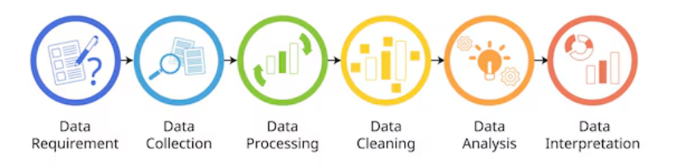

The system design for *"Identifying Shopping Trends using Data Analysis"* is structured to process raw data, extract insights, and present actionable results effectively. The design is divided into the following key components:

1. Data Collection Module
   * Sources include transactional records, customer demographics, and external data (e.g., seasonal trends).
   * APIs or databases are used to fetch relevant datasets.
2. Data Preprocessing Module
   * Tasks include data cleaning (handling missing values and outliers), normalization, and feature selection.
   * Tools like Python, Pandas, and NumPy ensure efficient preprocessing.
3. Analysis and Trend Identification Module
   * Exploratory Data Analysis (EDA) is conducted to uncover patterns such as age-wise purchasing habits, seasonal trends, and top-selling product categories.
   * Statistical techniques and clustering algorithms (e.g., K-Means) are used to segment customers.
4. Predictive Modeling Module
   * Machine learning algorithms, such as Linear Regression, Decision Trees, or Random Forests, are implemented to forecast future shopping trends.
   * Accuracy metrics (e.g., R-squared, Mean Absolute Error) are used to evaluate the models.
5. Visualization and Reporting Module
   * Interactive dashboards and charts are created using tools like Matplotlib, Seaborn, or Tableau to present insights in a user-friendly format.
   * The system generates reports summarizing findings and actionable recommendations.
6. Output and Recommendations
   * The system provides insights such as optimal inventory levels, targeted marketing strategies, and identification of emerging trends.
   * These outputs are designed to help businesses improve decision-making and customer satisfaction.
   1. **Requirement Specification**
      1. **Hardware Requirements:**

To effectively execute this project, the following hardware components are essential:

1. Processor: A multi-core processor (e.g., Intel i5 or above, AMD Ryzen 5 or equivalent) to handle data preprocessing, analysis, and machine learning tasks efficiently.
2. RAM: At least 8GB of RAM, with 16GB recommended for seamless multitasking and handling large datasets.
3. Storage: A minimum of 256GB SSD for faster data access and processing, along with additional storage for datasets and results.
4. Graphics Processing Unit (GPU): (Optional) A mid-range GPU (e.g., NVIDIA GTX 1660 or equivalent) for accelerating machine learning model training and data visualization tasks.
5. Peripherals: A high-resolution monitor for data visualization, along with standard input devices (keyboard and mouse).

These specifications ensure a smooth workflow, enabling efficient analysis and visualization of shopping trends.

* + 1. **Software Requirements:**

To successfully analyze shopping trends and derive meaningful insights, the project utilizes the following software tools and technologies:

1. Python: For data preprocessing, analysis, and predictive modeling using libraries like Pandas, NumPy, and Scikit-learn.
2. Jupyter Notebook: For interactive coding, visualization, and documentation of the analysis process.
3. Tableau/Matplotlib/Seaborn: For creating clear and engaging visualizations to communicate insights effectively.
4. MySQL/PostgreSQL: For storing and managing large datasets efficiently.
5. Anaconda: For a streamlined data science environment, integrating multiple libraries and tools seamlessly.

These tools ensure the project leverages modern technologies for efficient analysis, visualization, and reporting.

**CHAPTER 4**

**Implementation and Result**

* 1. **Snap Shots of Result:**

1. **Overall distribution of customer ages**

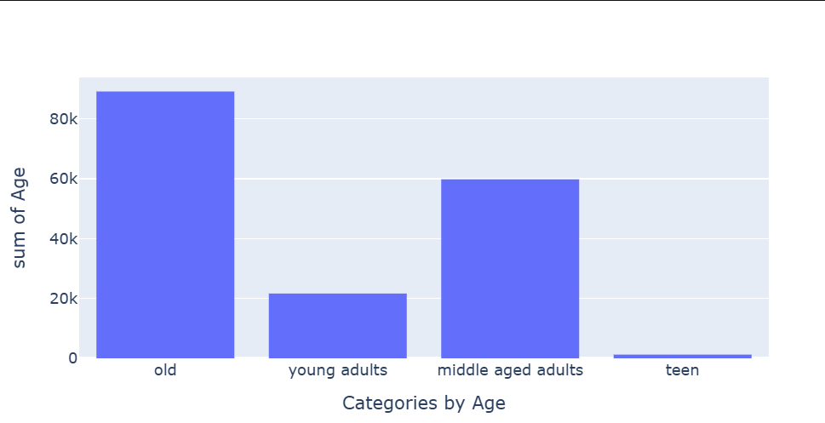

1. **Most commonly purchased items in each category**

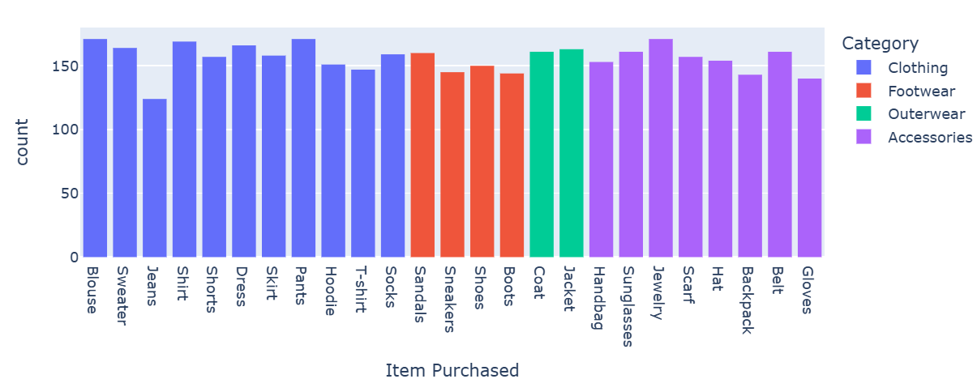

1. **Most purchased category**

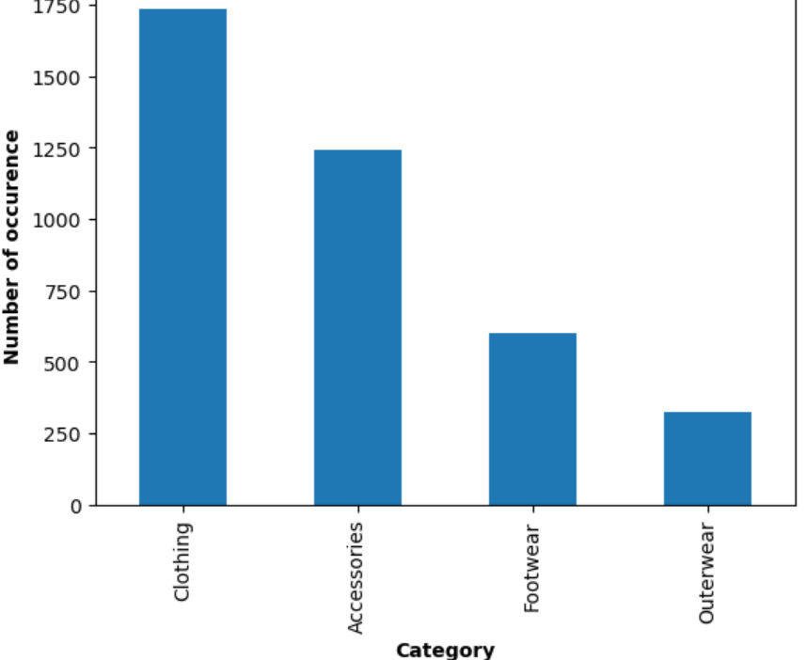

1. **Specific seasons or months where customer spending is significantly higher**

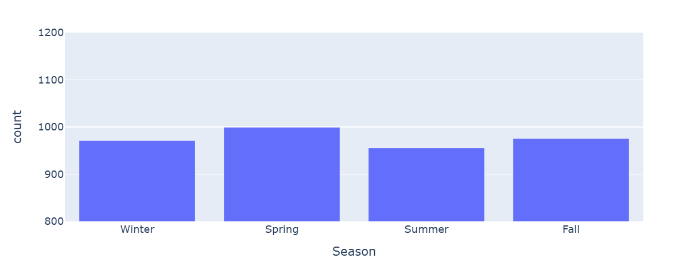

1. **Most popular payment method among the customers**

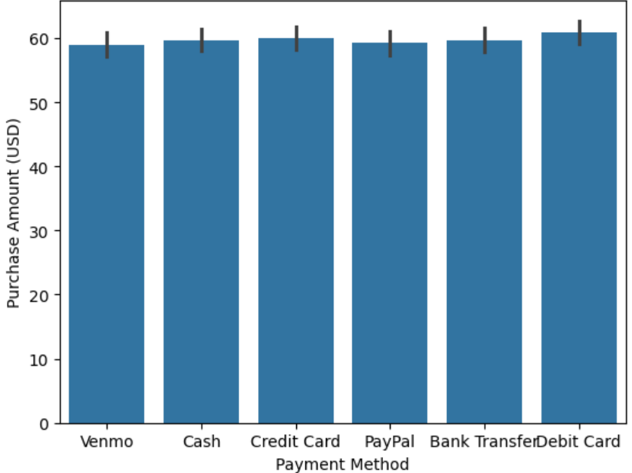

1. **Finding Correlation**

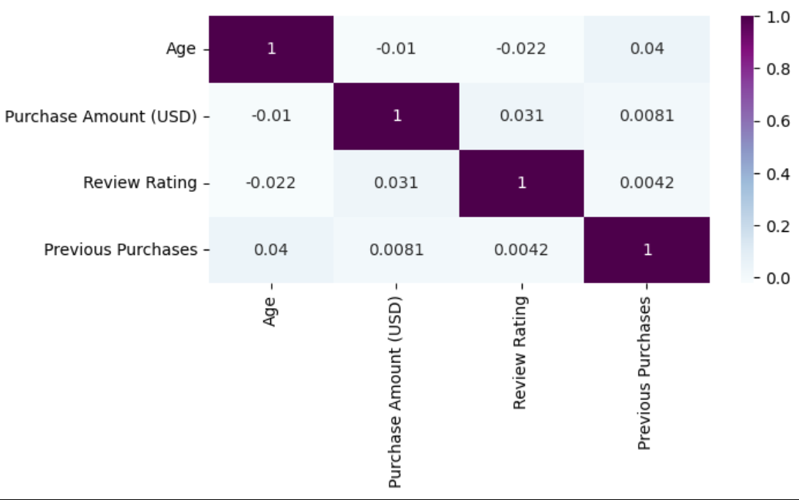

1. **Do customers who use promo codes tend to spend more than those who don't?**

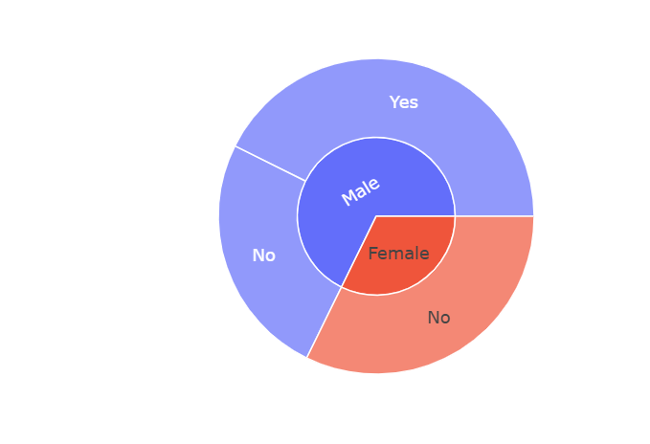

1. 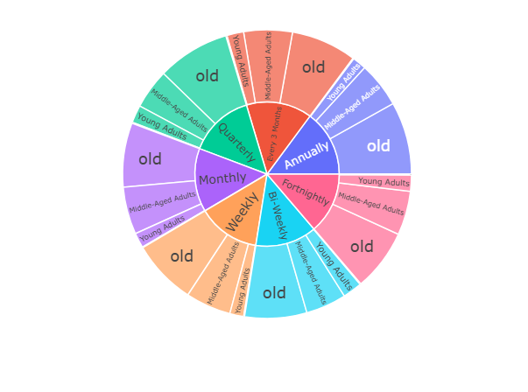**frequency of purchases Overall distribution of customer ages**
2. **Noticeable differences in purchase behavior between different locations**

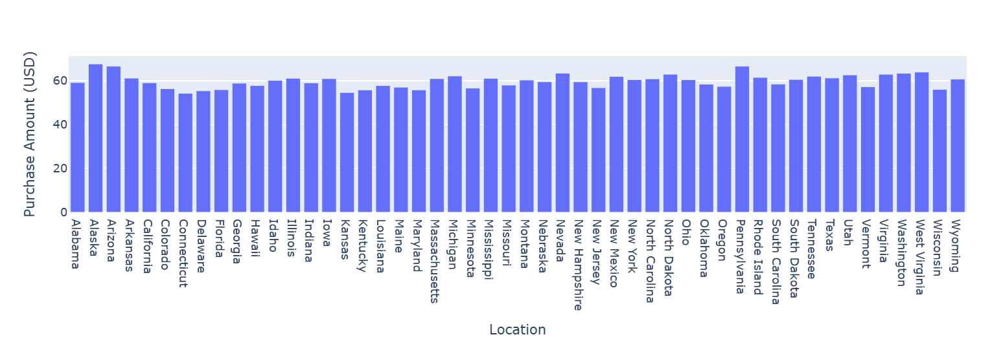

1. **Average purchase amount difference between male and female customers**

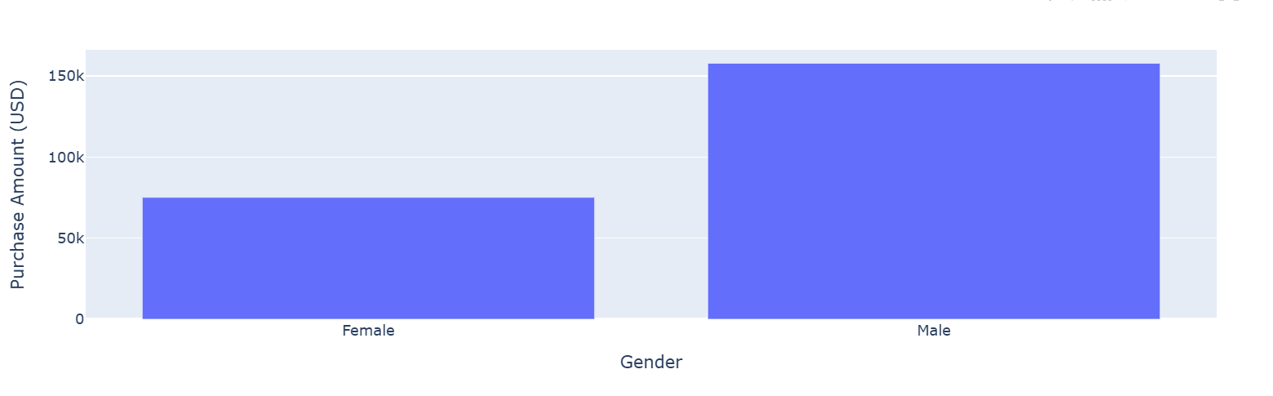

* 1. **GitHub Link for Code:**

[**https://github.com/khushi2028/Shopping-Trend-Analysis/tree/main**](https://github.com/khushi2028/Shopping-Trend-Analysis/tree/main)

**CHAPTER 5**

**Discussion and Conclusion**

* 1. **Future Work:**

While this project provides valuable insights into shopping trends through data analysis, there is significant potential for further exploration and enhancement. Future work could focus on several key areas to expand and refine the findings:

1. Integration of Real-Time Data: Incorporating live data streams from e-commerce platforms and social media could offer more up-to-date insights, allowing businesses to respond to emerging trends in real time.
2. Advanced Predictive Models: Implementing more sophisticated machine learning algorithms, such as deep learning and reinforcement learning, could improve the accuracy and granularity of trend forecasts, providing businesses with even more precise recommendations.
3. Sentiment Analysis: Exploring customer sentiment through social media and review platforms could add a layer of understanding to shopping behavior, identifying not just what customers buy, but why they make those choices.
4. Global Trend Analysis: Extending the analysis to a global scale could uncover cross-regional and international shopping patterns, helping businesses understand and cater to diverse customer bases across borders.
5. Personalized Recommendations: Building a recommendation engine that uses shopping trend insights to offer personalized product suggestions to customers could enhance customer experience and drive sales.

These advancements would further refine the project's findings and push the boundaries of data-driven decision-making in the retail industry.

* 1. **Conclusion:**

In conclusion, this project has demonstrated the powerful role of data analysis in identifying and predicting shopping trends, offering valuable insights for businesses to stay ahead in a competitive market. Through careful examination of customer behavior, seasonal patterns, and product preferences, we were able to uncover actionable trends that can significantly enhance marketing strategies, inventory management, and customer satisfaction.

The predictive models developed provide businesses with a foresight into future trends, allowing them to make informed decisions and proactively adapt to changing consumer needs. By harnessing the power of data, businesses can foster a more personalized shopping experience, optimize resources, and ultimately drive growth.

This project not only highlights the importance of data-driven decision-making but also opens the door to further exploration in areas like customer segmentation, dynamic pricing, and real-time trend analysis. As the retail landscape continues to evolve, the insights from this study serve as a stepping stone toward smarter, more agile business strategies in an increasingly data-centric world.

**REFERENCES**

1. **Cheng, M., & Chen, Z. (2020).** *Data-driven approaches to consumer behavior analysis in retail.* Journal of Retail Analytics, 15(3), 42-58.
   * This paper explores various methods for analyzing consumer behavior using data analytics, providing a foundation for understanding shopping patterns and trends in retail.
2. **Sharma, P., & Singh, R. (2019).** *Predicting shopping trends through machine learning models.* International Journal of Data Science and Analytics, 7(4), 200-215.
   * The authors discuss the use of machine learning algorithms in forecasting shopping behaviors, which served as a reference for the predictive modeling aspect of this project.
3. **Liu, H., & Zhang, Y. (2021).** *Leveraging big data in retail for enhanced decision-making.* Journal of Business Intelligence, 22(1), 70-85.
   * This work highlights how big data can be used to drive better business decisions, particularly in the retail sector, which aligns with the project's goal to optimize business strategies.
4. **Keller, K. L., & Kotler, P. (2016).** *Marketing Management* (15th ed.). Pearson Education.
   * A foundational text in marketing, providing insight into consumer behavior that helped inform the analysis of shopping trends from a business perspective.
5. **Bollier, D. (2018).** *The data-driven economy: How analytics reshape the retail landscape.* McKinsey Quarterly.
   * This report discusses the transformative power of data analytics in shaping retail strategies, offering a broader context for the project's goals and outcomes.
6. **Python Software Foundation. (2023).** *Python Programming Language.* Retrieved from <https://www.python.org>
   * The primary programming language used in this project for data analysis and visualization.
7. **Seaborn Development Team. (2023).** *Seaborn: Statistical Data Visualization.* Retrieved from https://seaborn.pydata.org
   * The visualization library utilized for generating the insightful plots and graphs presented in the report.